Connecting Vm Via Bastion

Bastion is s Service provided by azure to connect Vms without exposing Vm’s public/private IP .
It will use a url to access the Vm . so no need of RDP(3389), SSH (22) and NSG group .
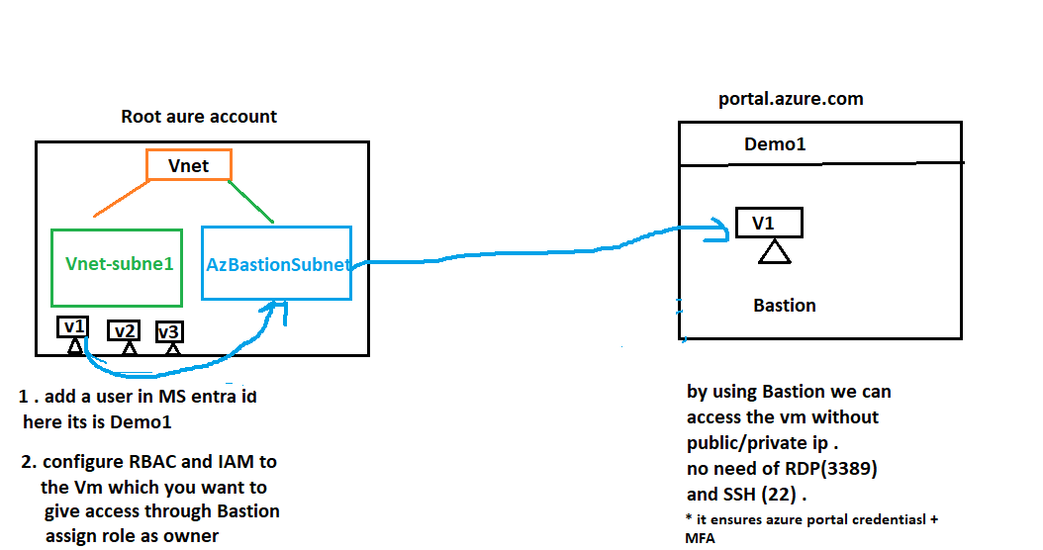
UseCase:
- When we don’t want to reveal Vm’s Public /private ip .
- When user is a external third party who wants access to vm
- When RDP and SSH port is not configured in Vm . If you don’t want to give RDP/SSh access to user
- When you need multiple security .
Requirements :
- One Virtual Network
- Two subnet ( one normal subnet and one bastion subnet
- One Bastion configuration
- One Primary user(itsmukeshgouda@gmail.com) and secondary user (Demo1@itsmukeshgouda@onmicrosoft.com )
- Few Vm in one subnet

Process :
- Create a Virtual Network , keep Ip range CIDR second classs i.e (172.16.10/25) .

- Search Virtual Network in azure portal and click create
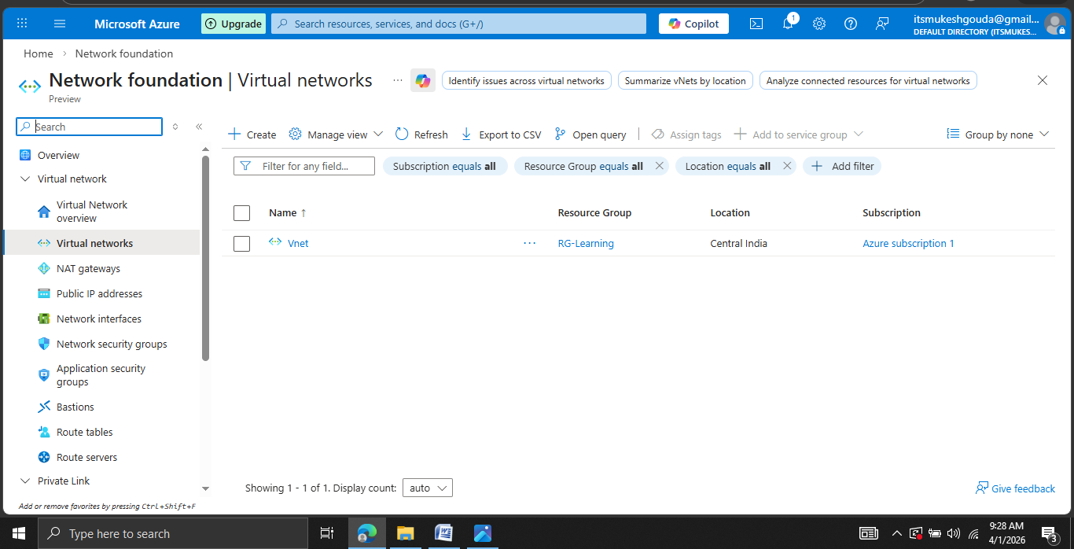
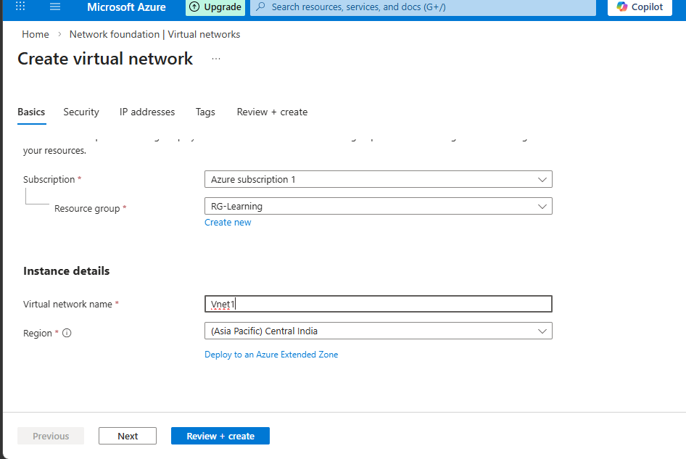
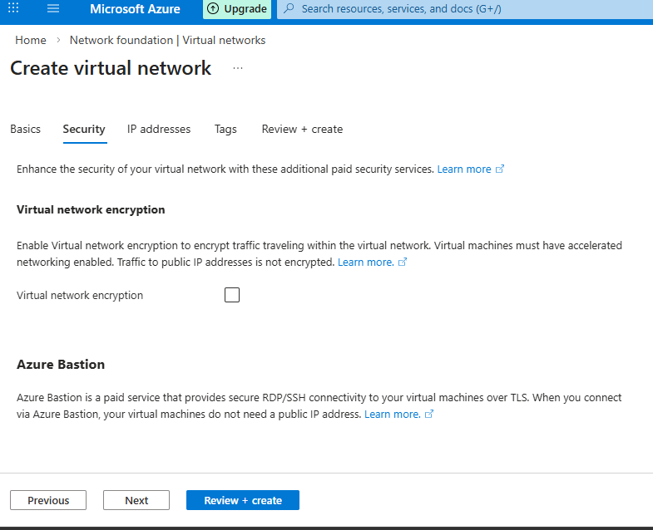
- Add ip range
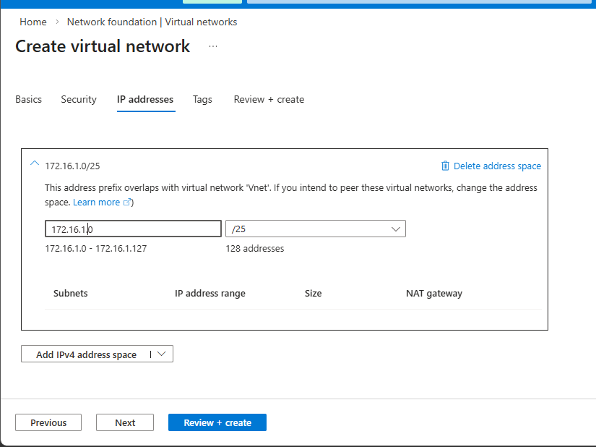
- Add a Subnet named Vnet-subnet-1
- Then crate a subnet called “Vnet-subnet-1” . ip range (172.16.1.0 – 172.16.1.64 )/26 .

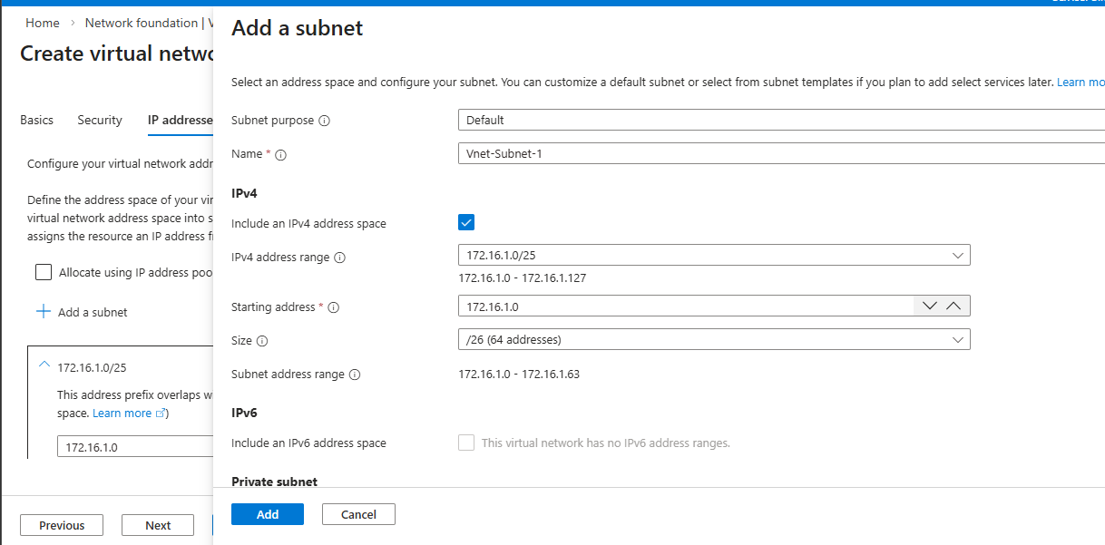
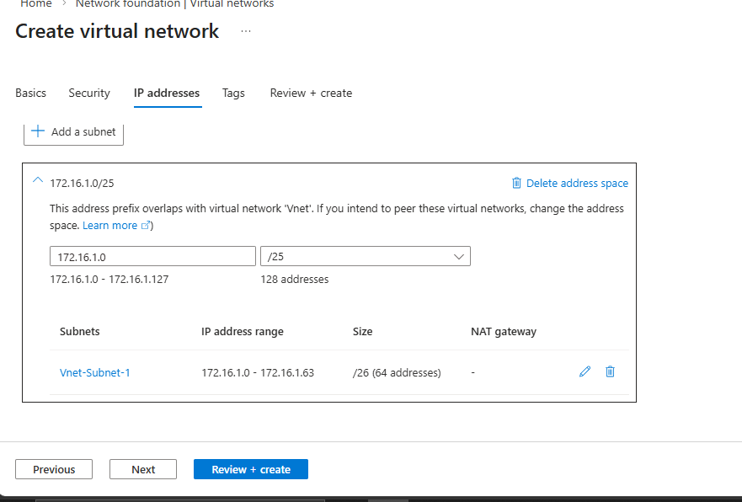
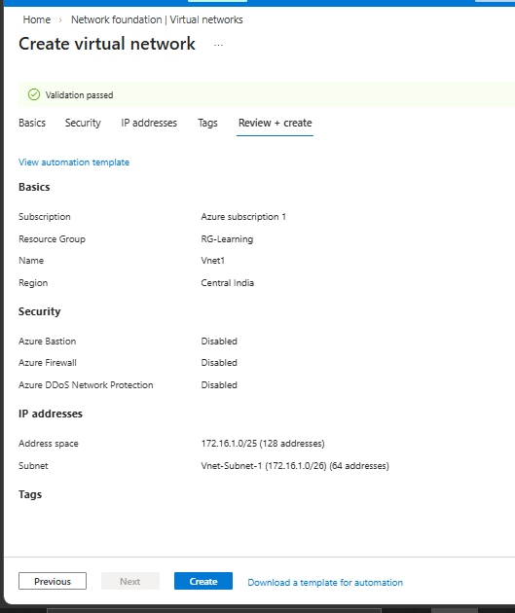

- Create a Vnet . here we created a vnet , then a subnet who will have 64 ips . rest 64 ips still there in the Vnet .
- Keep rest ip in Vnet unassigned will assign it whiles configuring Bastion.

- Create a Vm with disabling NIC Network Security Group (NSG ) and disable RDP and SSH port .so that no one can publicly access the Vm’s Ip and take RDP .
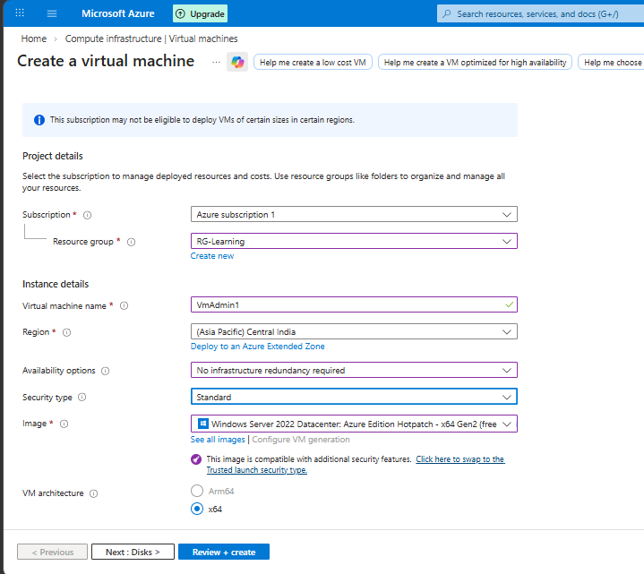

- You can see we have disabled all inbound rules so that no one can access via RDP and SSH
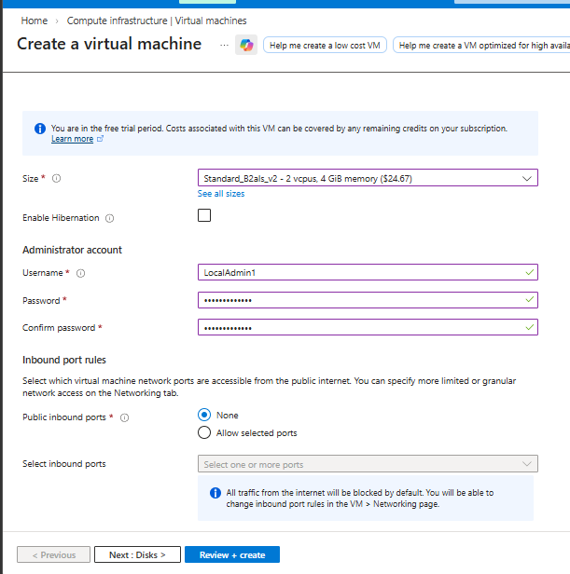
- Make sure in network panel you are selecting the configured Vnet and Vnet-subnet-1 . Its is the place where your Vm will be allocated .
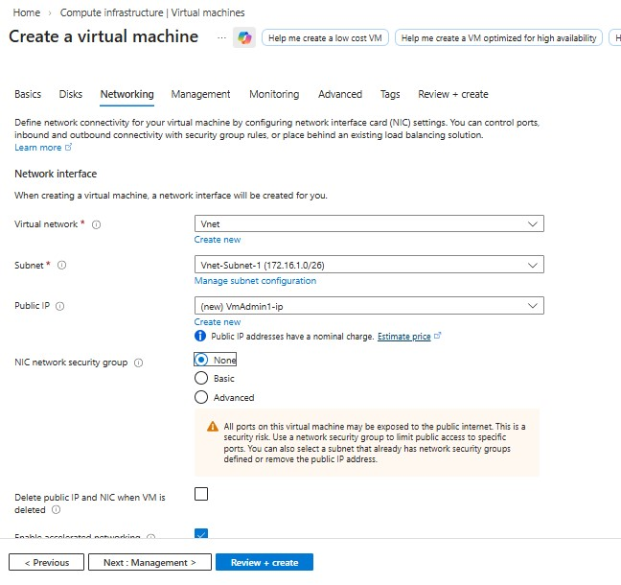
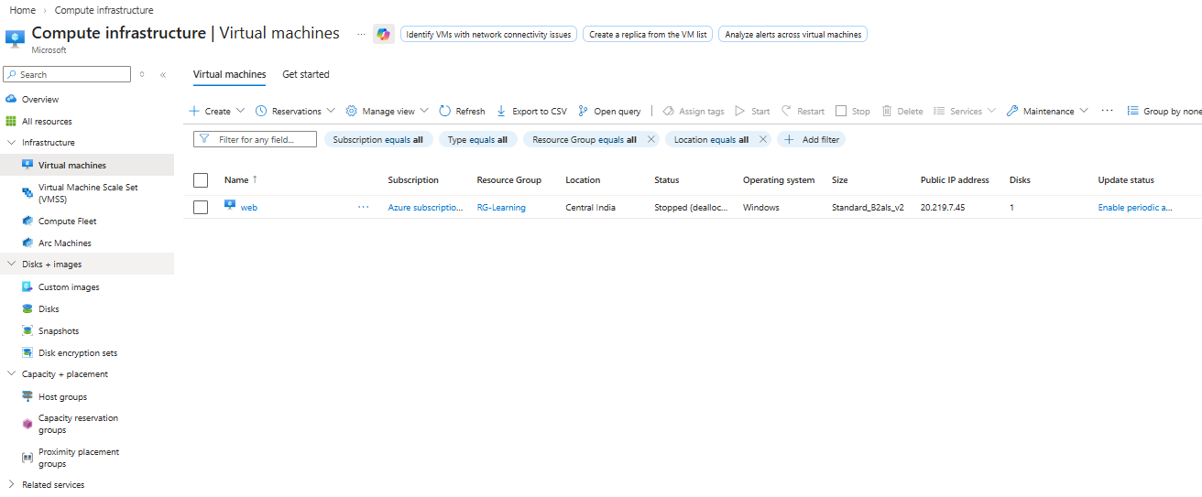
- After Vm creation goto the Vm -> select Bastion connect ->Deploy Bastion ( it will take max 10 min to configure Bastion ) .
- It will ask you to create a Bstion in Vnet . ensure both Vm and Bastion located in same Vnet .
- Configure Bastion , it may bydefault take “zureBastionsubnet”.
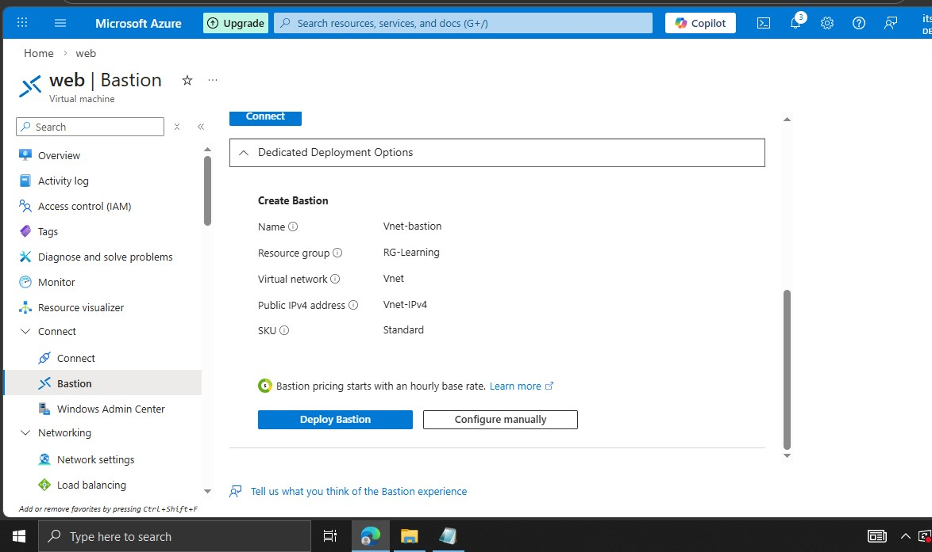
- After the bastion configured select “Deploy Bastion” and Give User and password which you had created during the Vm creation .
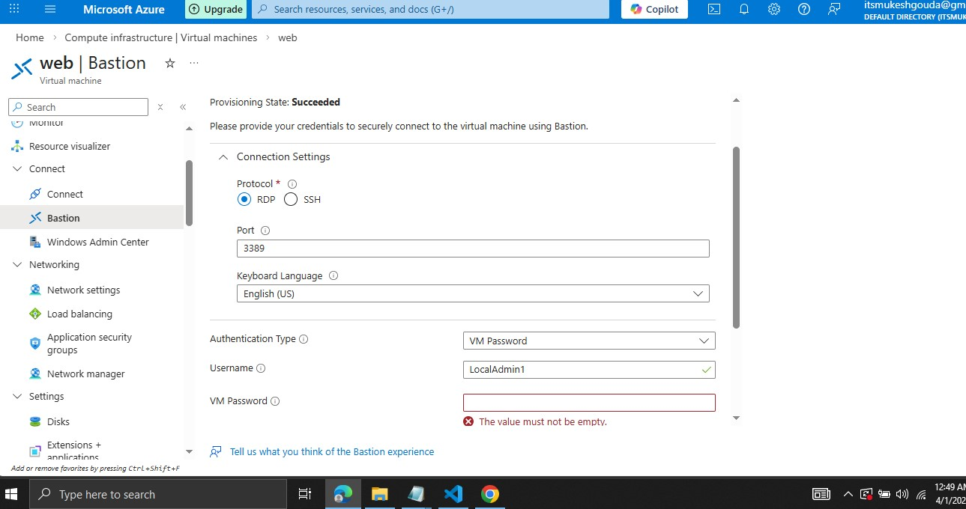
- Then it will allow you to Connect to the Vm Via Bastion without any Public/private/RDP/SSH .
\
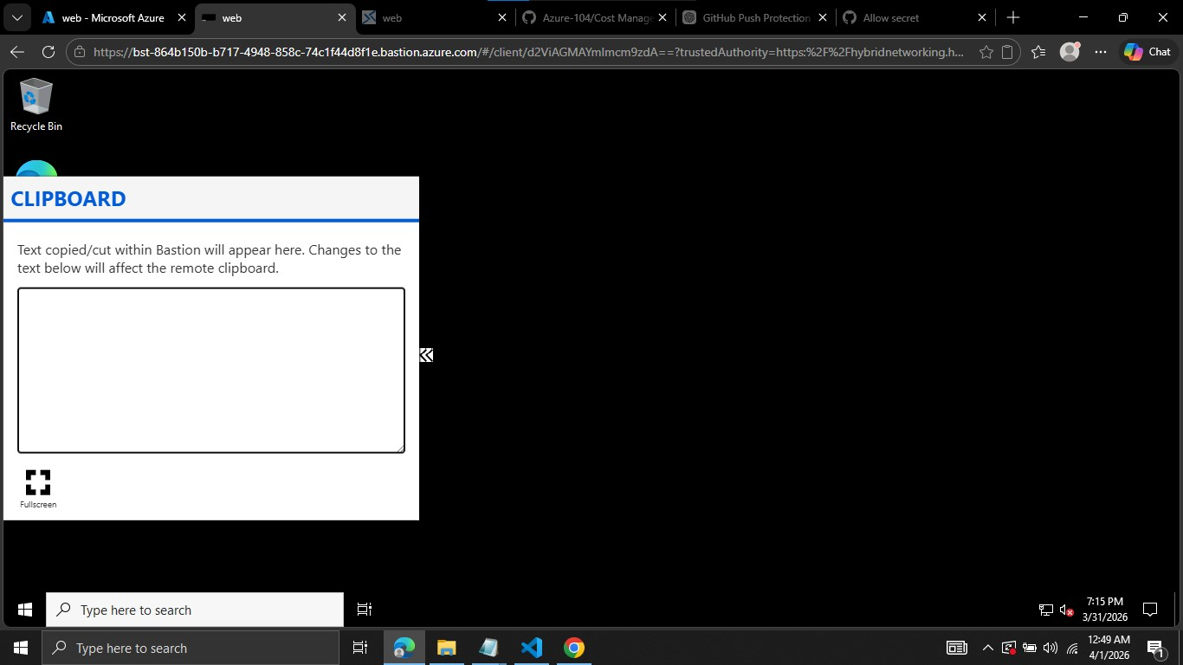

This is done in User Account .

Now will try to access the Vm by another user which is Demo1.
Since its not having access , it will not allow to access the Vm .
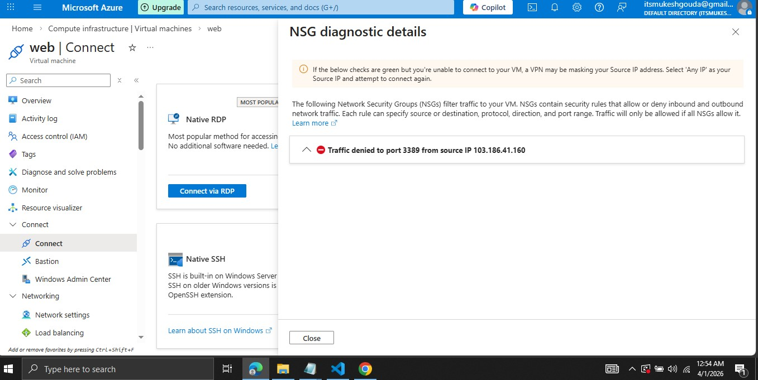
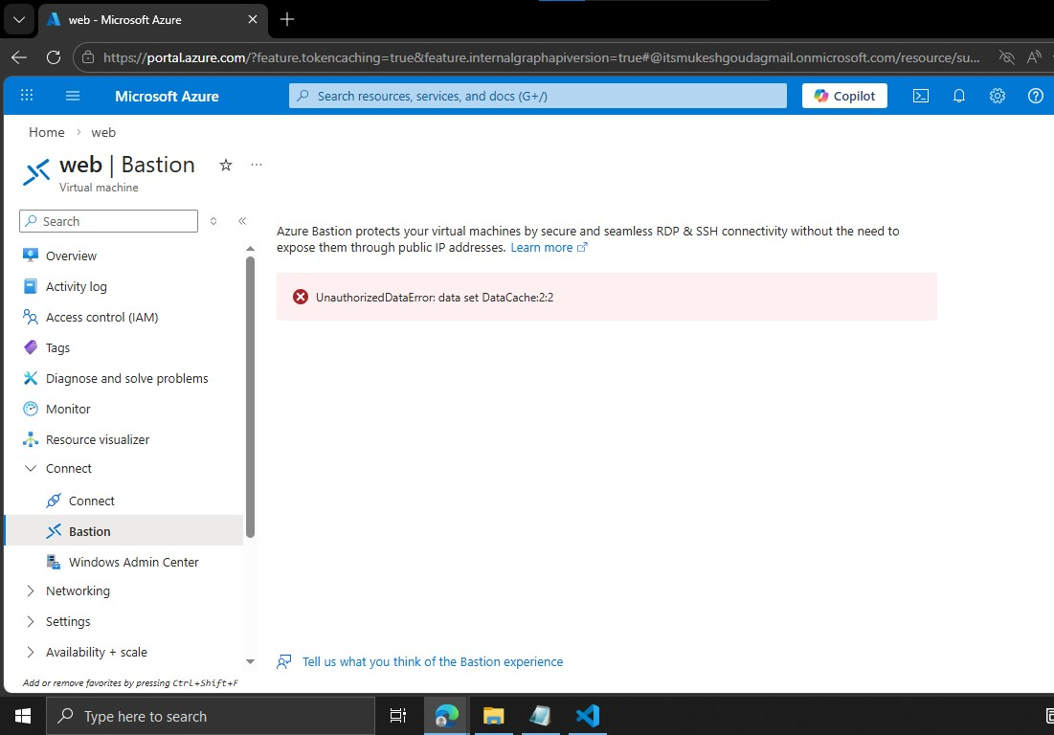

You need to assign user Demo1 a “Privileged assignment” Owner or Contributor rule to Resource group (RG-Learn ) and add a member into that rule .so that user Demo1 have Privilege to access the Vm Via Bastion .
